ShuntLogger

Real Time Clock DS1307
https://arduinogetstarted.com/tutorials/arduino-ds1307-rtc-module
GND <-> GND
VCC <-> 5V
SDA <-> A4 on Uno
SCL <-> A5 on Uno

SD-Karten Modul
SD <-> Arduino
1 <-> CS 10 3,6 <-> GND
2 <-> SDI 11 4 <-> 3V3
5 <-> SCK 13
7 <-> SDO 12
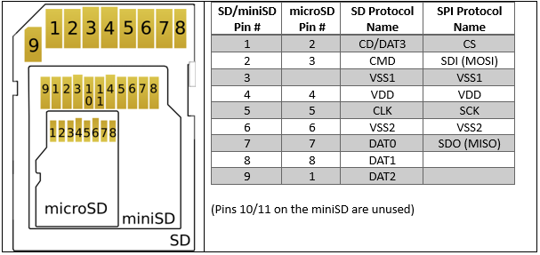
- Logik-Pegelwandler 74HC4050D
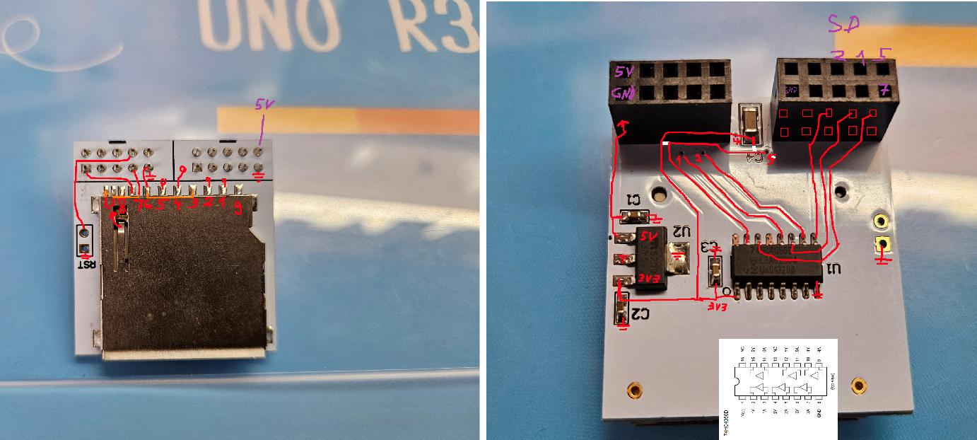
SD-Modul | Arduino UNO Pin

CS | 10

MOSI | 11

MISO | 12

SCK | 13

VCC | 5V

GND | GND

